**Vocational school for computer programming and innovation**



**Sets C++ Project**

|  |  |
| --- | --- |
| **Made by:** | **Roles:** |
| Hristo Hristov  Email: [HSHristov18@codingburgas.bg](mailto:HSHristov18@codingburgas.bg) | Scrum Trainer |
| Plamen Kostov  Email: [PKKostov18@codingburgas.bg](mailto:PKKostov18@codingburgas.bg) | Developer 2 - C++ |
| Ilian Yanev  Email: [IMYanev18@codingburgas.bg](mailto:IMYanev18@codingburgas.bg) | Developer 1 – Front End |
| Kristian Lalev  Email: [KALalev18@codingburgas.bg](mailto:KALalev18@codingburgas.bg) | Developer 3 – Code Checker |
| Plamen Petkov  Email: [PCPetkov18@codingburgas.bg](mailto:PCPetkov18@codingburgas.bg) | Developer 2 - C++ |

Contents

1.Description of the project 4

2.Diagram of the project 5

3.Functions and how they work 7

# 1.Description of the project

* + The project is about actions of sets in C++ language.
  + The project contains a couple of multiple actions. They are: "merge", "section", "The difference (A\B)", "The difference (B\A)", "Symmetrical difference" and "Subset".

# 2.Diagram of the project

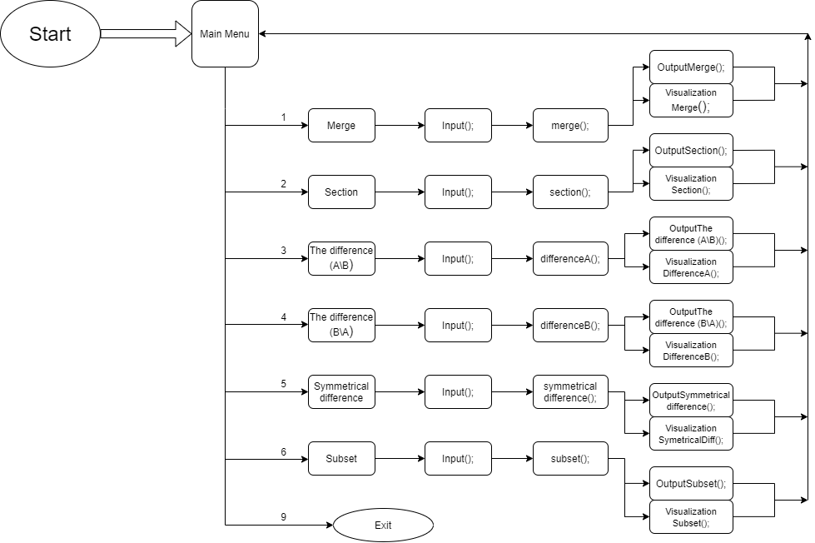

# 3.Functions and how they work

|  |  |  |
| --- | --- | --- |
| **Functions** | **Description of the function** | **Return value of the function** |
|  | This function inputs the sets elements. | This function doesn’t return value because it is of type void. |
|  | This function compares the two sets. | It returns the variable of type int. |
|  | This function inputs the size of the first and second set and outputs the merge between the sets. | This function doesn’t return value because it is of type void. |
|  | This function compares the two sets. | It returns the variable of type int. |
|  | This function inputs the size of the first and second set and outputs the section between the two sets. | This function doesn’t return value because it is of type void. |
|  | The function shows the menu that you choose options of actions of sets. | This function doesn’t return value because it is of type void. |
|  | Visualizes the figure that presents the merge between the two sets. | This function doesn’t return value because it is of type void. |
|  | Visualizes the figure that presents the section between two sets. | This function doesn’t return value because it is of type void. |
|  | Visualizes the figure that presents the difference (A\B) between two sets. | This function doesn’t return value because it is of type void. |
|  | Visualizes the figure that presents the difference (B\A) between two sets. | This function doesn’t return value because it is of type void. |
|  | Visualizes the figure that presents the symmetrical difference between the two sets.  . | This function doesn’t return value because it is of type void. |
|  | Visualizes the figure that presents the subnet between the two sets. | This function doesn’t return value because it is of type void. |